Optimization Using ODE Methods
By: Shin Lin, Genevieve Merecki, Christine Worley & Asher Vellekamp

Abstract
This project investigates whether using advanced numerical ODE methods can improve optimization efficiency. We tested four methods: Runge-Kutta 4, Adams-Bashforth 3, Adams-Moulton 3, and Backward Euler. To evaluate their effectiveness, we applied them to five benchmark functions [1], all of which are convex and differentiable. It was expected that these methods would outperform Euler’s method since they use higher-order approximations instead of only the first order or have some other advantageous feature, such as increased stability. These methods increase the accuracy of the trajectory and, in theory, result in faster convergence, hopefully proportionate to the increase in gradient evaluations. However, in implementing the selected ODE methods, we found that gradient descent outperformed alternatives, consistently reaching convergence with fewer steps and fewer gradient evaluations.

Introduction/Motivation
The main motivation for this study is to see if there are better ways to optimize a function rather than the commonly used gradient descent. Gradient descent is straightforward and effective for finding the minimizer using Euler's method (an explicit, one-step, first-order method). In this project, we used four different ODE methods to evaluate five different functions. We modified gradient descent to implement higher-order ODE methods* and compared the performance to Euler's method. We want to know if using these methods of better approximation of trajectory actually leads to a more efficient convergence.
The primary theory being tested is that higher-order ODE methods will allow for larger step sizes to be used, leading to fewer iterations of the method because of their more accurate trajectory approximation. However, the computational costs for the methods used in this experiment are either equivalent or higher in terms of gradient evaluations. Gradient evaluations are one of the most expensive steps in optimization, so minimizing them is key to improving efficiency.
Hence, in order for these methods to be worthwhile, the step size must be proportionately larger than the number of gradient descent evaluations. The hypothesis of this experiment is that the increase in accuracy and stability of these methods will lead to fewer iterations (faster convergence) through increased step size. The other aspect of this hypothesis is that the increase in speed of convergence will be enough to balance out the number of gradient evaluations, even with increased evaluations per step. By reducing the number of evaluations that need to be performed, the computational and time cost of solving these problems would decrease, increasing how effectively these problems can be solved.

*Except for Backward Euler, which has the same order of accuracy as Euler's method in terms of ODE solving, but has other advantages that are discussed in the "Proposed Methods" section.

Proposed Method
In order to test whether numerical ODE methods can solve an optimization problem better – in other words, find the minimizer faster – the code for gradient descent will be changed to multiply each step size by a step of the ODE methods instead of the gradient for each iteration. Then, the results will be compared to determine which method can get to the minimizer with the least number of iterations tested on five convex and differentiable benchmark functions, some stiffer than others. The amount of gradient evaluations done for each method is the overall evaluation metric since those evaluations are the main contributors to computational cost, and each method might not have the same amount of gradient evaluations per iteration. The experimental results will test whether any of these ODE methods will consistently have fewer gradient evaluations across our five functions. Also, the methods will be compared to see if they have steeper slopes on a logarithmic graph of iterations versus gradient norm in comparison with gradient descent since that might be informative on their order of convergence rate regardless of the number of gradient evaluations.
There are a total of 4 numerical ODE methods in this experiment proposed as alternatives to Euler’s method for gradient descent. Two of the methods are explicit methods, Runge-Kutta 4 (RK4) and Adams-Bashforth 3 (AB3), and two are implicit methods, Backward Euler and Adams-Moulton 3 (AM3). They are compared to Euler’s method, which is also an explicit linear multistep ODE method, but it is the same as gradient descent (GD).
$x_{n+1}=x_{n}-h⋅∇f(x_{n})$
As an ODE method, Euler’s is first order accurate and one of the simplest of all linear multistep methods - a one-step method to be specific. This means it approximates the trajectory of a first order ODE with the error being proportional to the step-size, $O(h)$. It is important to note, though, that it has a convergence rate to the minimizer with $O\left(\frac{1}{\sqrt{h}}\right)$ - $O\left(\frac{1}{h}\right)$ for convex functions - which is what we are really interested about, but right now we only have information on order of accuracy for the ODE methods.
Of the explicit ODE methods, Runge-Kutta 4 is a fourth order one-step numerical method. The method is given:
$x_{n+1}=x_{n}-\frac{h}{6}\left(k_{1}+2k_{2}+{2k}_{3}+k_{4}\right)$
where $k_{1}=∇f(x_{n}), k_{2}=∇f(x_{n}+\frac{h⋅k_{1}}{2}), k_{3}=∇f(x_{n}+\frac{h⋅k_{2}}{2}), k_{4}=∇f(x_{n}+{h⋅k}_{3})$.

Theoretically, this means it is four times as accurate in predicting a trajectory compared to Euler’s method $O(h^{4})$. Thus the hypothesis is that it could achieve convergence with step sizes at least four times as large as the step sizes for Euler’s method, since this method computes the gradient four times in one iteration. If it is unable to do this, it won’t be able to outperform gradient descent, however RK4 is only linearly stable and cannot converge with step sizes too large[2]. However, there have been similar studies on improving optimizers by Runge-Kutta method [3], in which they used RK4 in place of gradients for stochastic gradient descent (SGD) for training neural networks. They yielded results in favor of the RK4-SGD method, when used in a problem with stochasticity and approximate gradients. Another study used Runge–Kutta Chebyshev in their descent method [4], which fixes the problem of instability for stiff ODEs and large step sizes. Therefore the experiment includes RK4 with evidence that it could yield better results, though it’s still notable that both experiments mentioned technically use different strategies than what is proposed here.
Our other explicit method, Adams-Bashforth 3, is a linear multistep method, given by:
$x_{n+3}=x_{n+2}-\frac{h}{12}\left(23∇f(x_{n+2})-16∇f(x_{n+1})+5∇f(x_{n})\right)$.
Since it is a linear multistep method, the code uses Euler’s method to determine the first gradient, and AB2 to determine the second gradient. AB3 is also only conditionally stable, however it only requires one gradient evaluation per iteration, as the past three gradient evaluations are saved in a list to reuse. On the other hand, it is only third order accurate, $O(h^{3})$, whereas RK4 is fourth order accurate. Nonetheless, it is good to mention here that these are orders of accuracy to the true trajectory of the function given an initial value and not the convergence rate to the minimizer itself. Whether these higher accuracies can improve the convergence rate and computational cost is the crux of the experiment.
Contrary to explicit ODE methods, implicit ODE methods are much more stable. Backward Euler, for one, is unconditionally stable, with formula as follows:
$x_{n+1}=x_{n}-h⋅∇f(x_{n+1})$
One can see it is very similar to the forward Euler’s method, except it uses $x_{n+1}$ instead of $x_{n}$ for the gradient evaluation, and it also first order accurate: $O(h)$. This means the value at the next step must be known to solve the next step, creating a small optimization problem in itself. To do this, an inner “fix point iteration” is performed for each iteration of the optimization problem. Essentially, for every iteration, there will be an inner loop that evaluates the ODE method until the solution is the same as the input value. Although this allows the method to become much more stable so larger step sizes may be applicable, it creates this inner loop that can potentially evaluate the ODE method over and over many times until it reaches the tolerance where the input is approximately the evaluation. Not only that this may introduce a lot of computational cost, it could also be not as fruitful since getting to the minimizer, that is decreasing our function value by all means, is our first objective, and not finding the best trajectory. However, if this allows the algorithm to take huge steps that successfully decrease the function value without doing too many iterations in the inner loop, there may still be a chance of getting to the minimizer with less computational cost. Though to emphasize again, even if huge step sizes are taken without much additional cost, they are just values that are really close to the real trajectory but not necessarily the best descent direction, since numerical ODE methods inherently solve different problems than an optimizer.
The last method, AM3, though it is also implicit, is considered only weakly stable. Since it is also a multistep method, we used Euler’s method to solve for the first gradient and AM2 (essentially the implicit trapezoid rule) to solve for the second gradient. The actual AM3 is as given:
$x_{n+3}=x_{n+2}-\frac{h}{24}\left(9∇f(x_{n+2})+19∇f(x_{n+2})-5∇f(x_{n+1})+∇f(x_{n})\right)$
Its stability range is definitely much larger than AB3, in which the stability range is around 500 times larger in radius [8]. Additionally, although it is a linear three step method like AB3, its order of error is $O(h^{4})$ since it is implicit [5]. This lets its order of error be the same as RK4 but not necessarily at an advantage to it, since it might require many inner loops for the fix point iterations just like Backward Euler.
The methods will be tested on these five benchmark functions [1], the Sphere, Brent, Matyas, Bohachevsky, and the Exponential function, in which their formulas are as follows:
Sphere: $f(x_{0}+x_{1}+{⋅⋅⋅+x}_{n})=\sum_{i=0}^{n}{}{x_{i}}^{2}$
Brent: $f(x,y)=(x+10)^{2}+(y+10)^{2}+e^{−x^{2}−y^{2}}$
Matyas: $f(x,y)=0.26\left(x^{2}+y^{2}\right)-0.48xy$
Bohachevsky: $f(x,y)=x^{2}+2y^{2}−0.3cos(3πx)−0.4cos(4πy)+0.7$
Exponential: $f(x_{0}+x_{1}+{⋅⋅⋅+x}_{n})=−exp(−0.5\sum_{i=0}^{n}{}{x_{i}}^{2})$
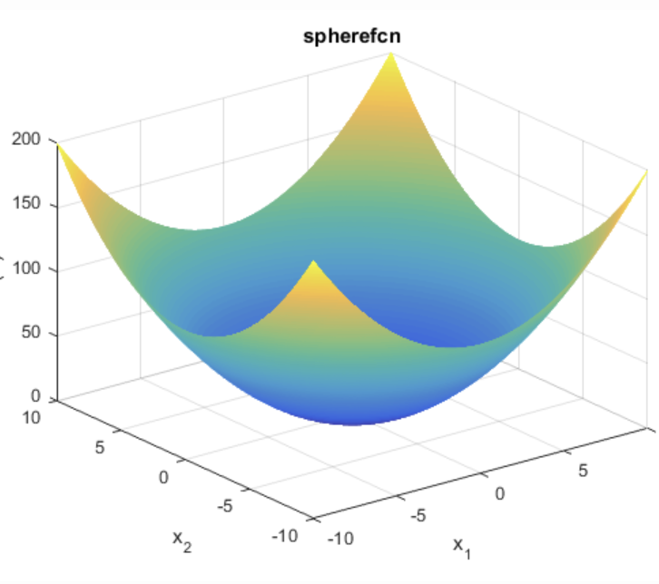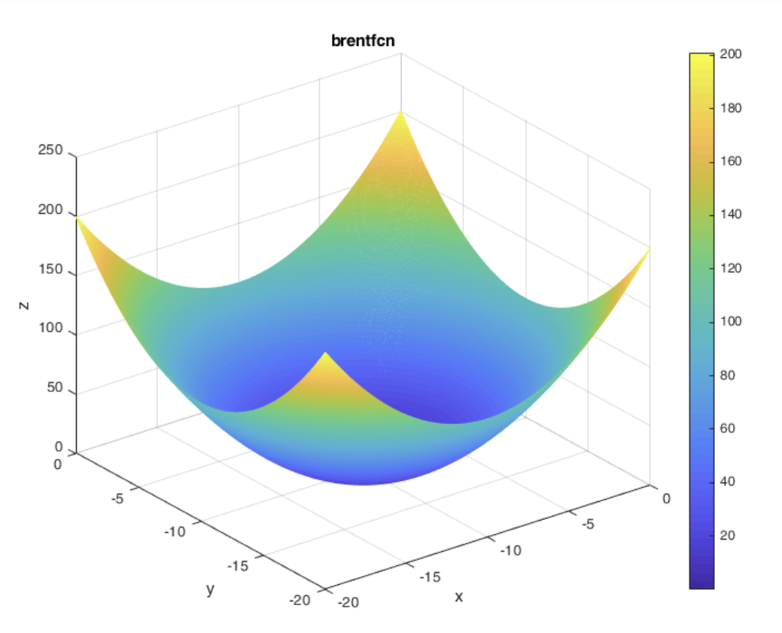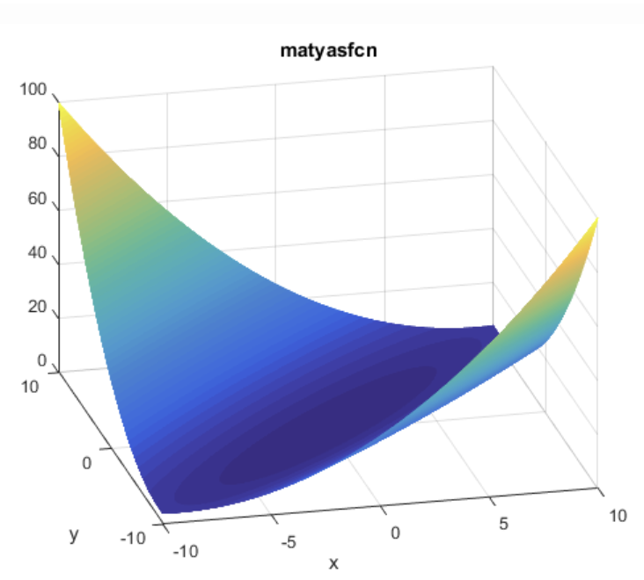
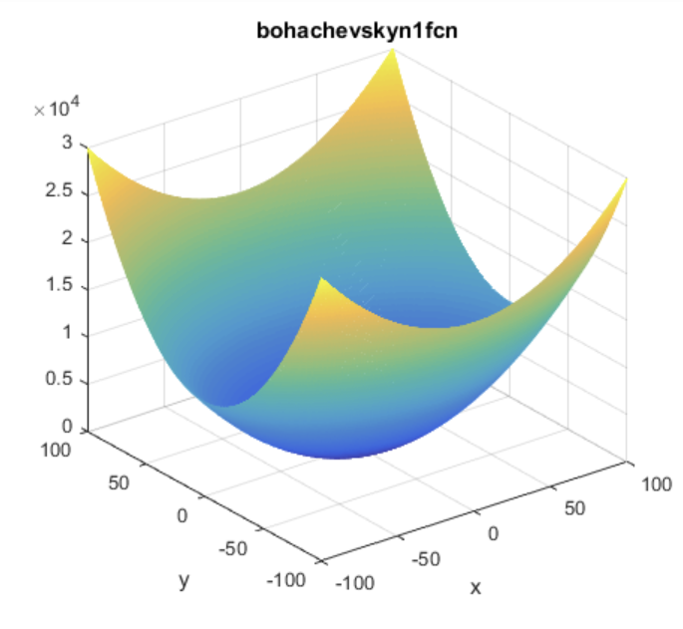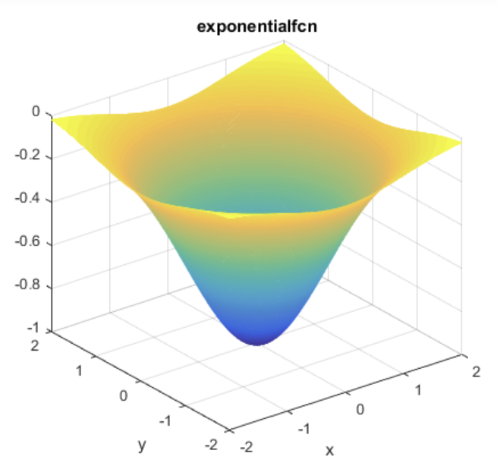
Figure 1: A collection of plots depicting the shapes of the functions used in this experiment

These particular functions were chosen because they are differentiable and convex, two of the most basic assumptions for gradient descent. At the beginning of the experiment, there was some idea to try more complex functions as results came in, but it proved unnecessary to test the methods on more complex functions since they didn’t work in the simplest cases, as discussed below.

Experimental Results
The metric used to evaluate the computational cost of these methods was the number of gradient evaluations. However, this was found to be challenging to express on a graph, so the decision was made to express the plot on the left-hand side with the x-axis as the number of iterations and the y-axis as the gradient norm. This leaves some interpretation to the reader since each iteration does not correspond to one gradient evaluation. In fact, except in the case of Euler’s method and Adams-Bashforth 3, each method has multiple gradient evaluations per step. These are also expressed as log-log plots because the paths wouldn’t all fit on the plot otherwise. The interpretation is best understood through the tables in conjunction with the figures.
For each step, there are about four gradient evaluations for Runge-Kutta 4. Based on the setup for Adams-Bashforth 3, there is only one gradient evaluation per iteration. For Backward Euler and Adams-Moulton 3, their fix point iterations are coded to max out at 100 and 1000 iterations respectively, but they usually converge earlier than that. Hence, for the explicit methods, the computational cost is approximately the number of gradient evaluations per step times the number of iteration, and for the implicit methods, it may vary, and will be more accurate to refer to the table.

Sphere
 | Gradient Descent | RK4 | AB3 | Backward Euler | AM3
Step Size | 0.5 | 0.7 | 0.5 | 0.4 | 0.5
Avg Steps | 1.0 | 10.8 | 1.0 | 13.8 | 1.0
Avg Gradient Evaluations | 2.0 | 44.2 | 2.0 | 90.2 | 3.0
Table 1: Table summary of results from Sphere function

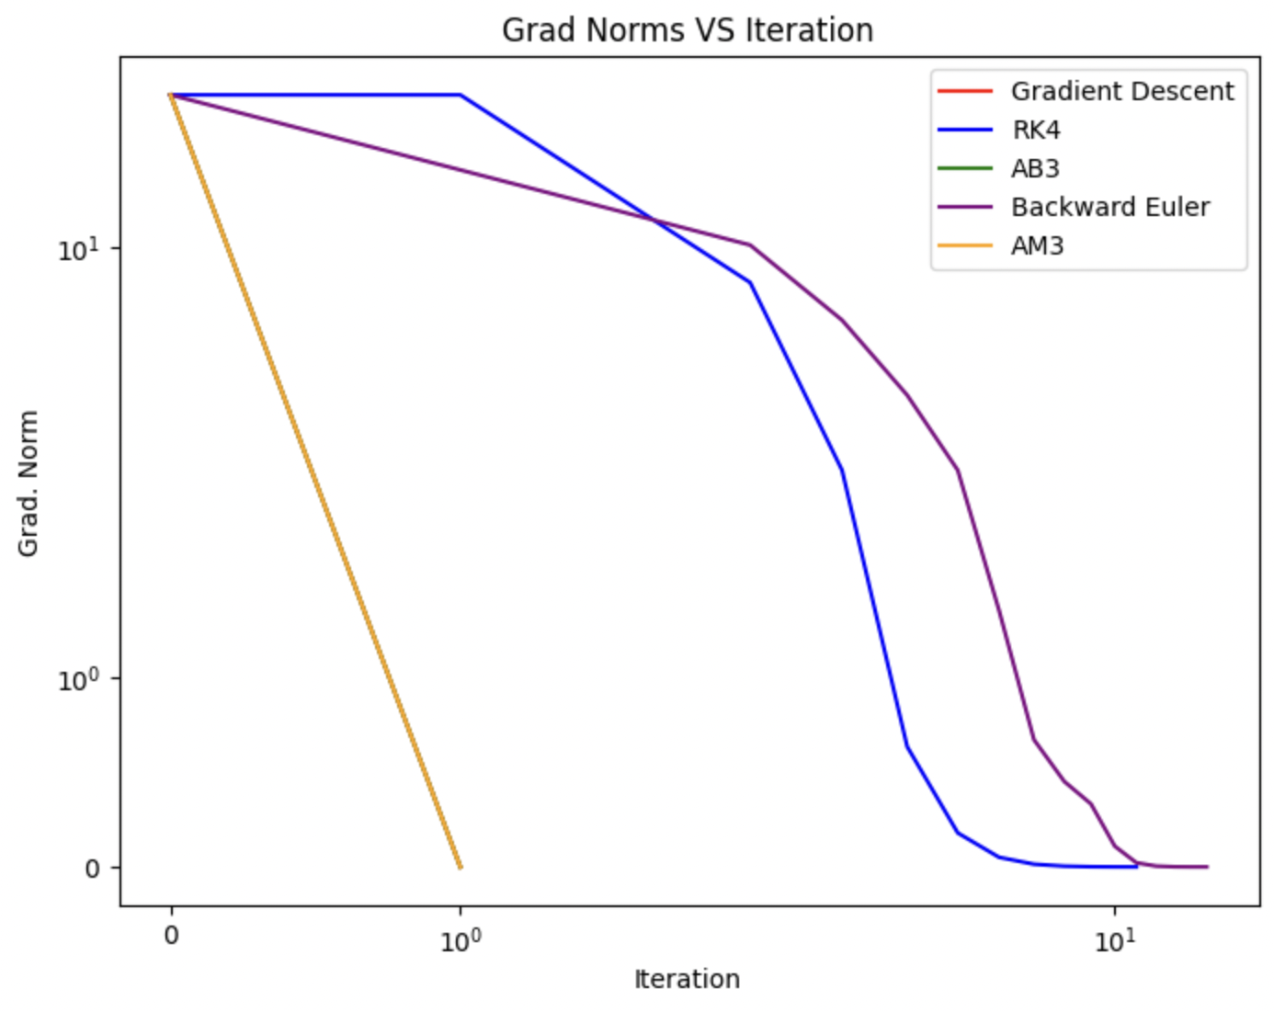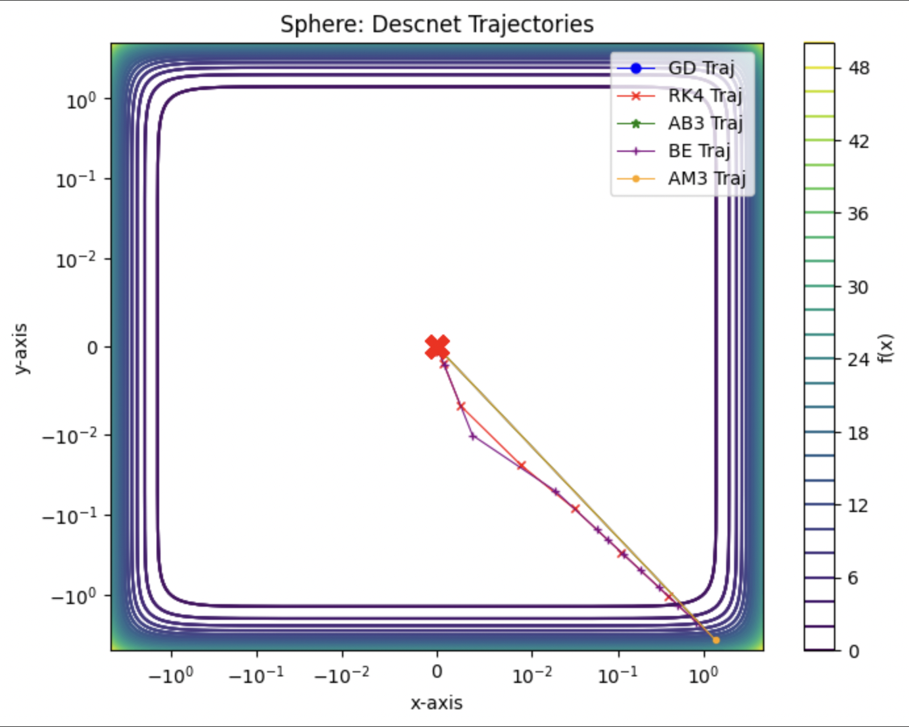
Figure 2: The plot on the left displays the gradient norm by number of iterations for the 5 methods used for the Sphere function. The plot on the right displays the trajectories for the 5 methods used for the Sphere function. Their results match each other.

In the case of the Sphere function, we see that AB3 and Euler’s converge in one step for the optimal step size (0.5) because of the specific analytical solution to this function, so these paths were not included in the left plot of Figure 2. AM3 is the next most efficient method, converging in an average of 3 gradient evaluations based on Table 1. The paths to the minimizer are basically exactly the same for gradient descent, AB3, and AM3 based on the right plot of Figure 2. Backward Euler and RK4 took a distinctly different path, and ultimately ended up taking the most iterations.

Brent
 | Gradient Descent | RK4 | AB3 | Backward Euler | AM3
Step Size | 0.5 | 0.75 | 0.5 | 0.4 | 0.5
Avg Steps | 1.0 | 9.8 | 2.0 | 20.8 | 1.0
Avg Gradient Evaluations | 2.0 | 50.0 | 1.0 | 2101.8 | 3.0
Table 2: Table summary of results from Brent function

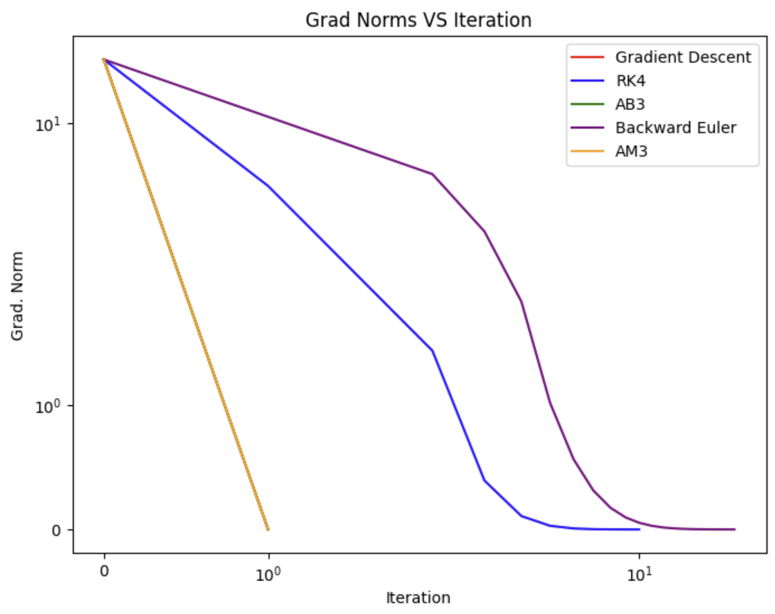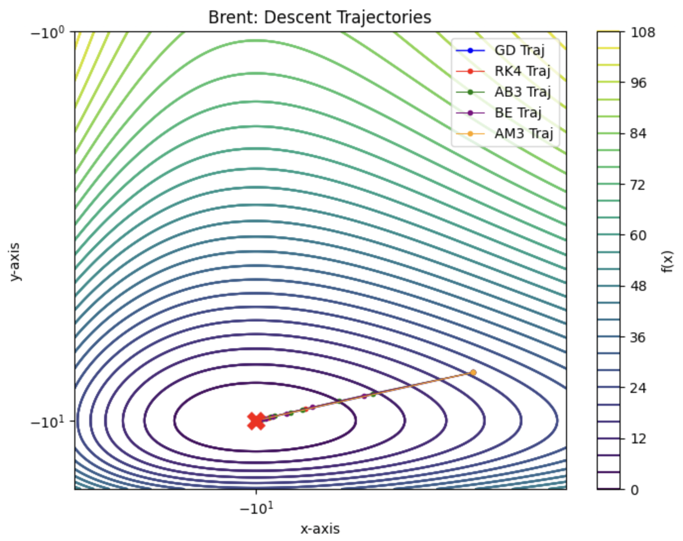
Figure 3: The plot on the left displays the gradient norm by number of iterations for the 5 methods used for the Brent function. The plot on the right displays the trajectories for the 5 methods used for the Brent function. Their results match each other.

In the case of the Brent function, we see that gradient descent with Euler’s method once again converges in one step, and is not included on the left side plot in Figure 3. Based on the left side plot in Figure 3, the second fastest method in terms of steps is AM3, with an average of 3 gradient evaluations based on Table 2. The paths of all methods are identical based on the right side plot in Figure 3.

Matyas
 | Gradient Descent | RK4 | AB3 | Backward Euler | AM3
Step Size | 1.8 | 0.7 | 0.5 | 0.75 | 1.3
Avg Steps | 94.8 | 252.2 | 352.6 | 238.8 | 113.6
Avg Gradient Evaluations | 95.8 | 1262.0 | 353.6 | 2627.8 | 424.4
Table 3: Table summary of results from Matyas function
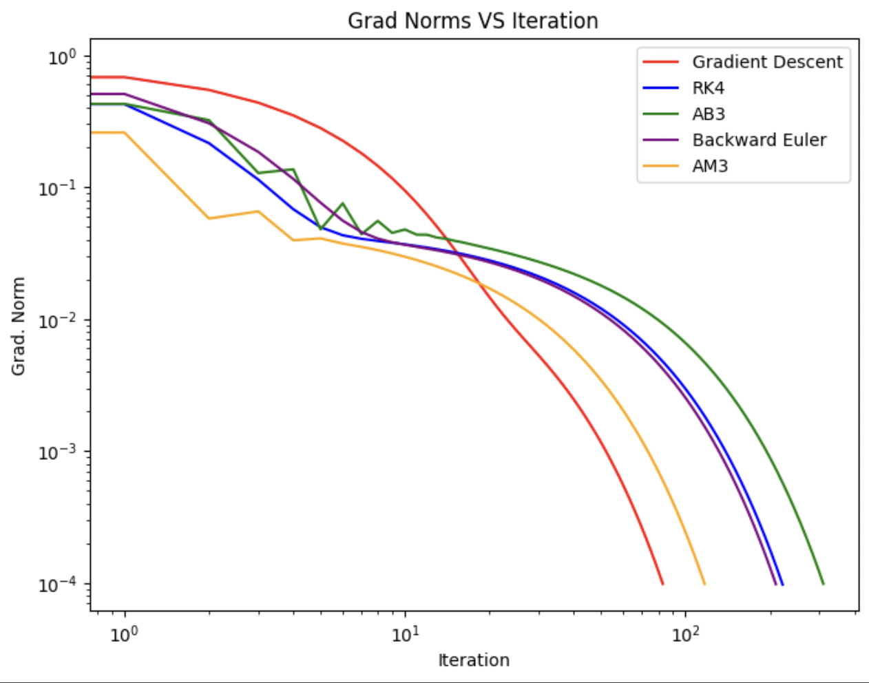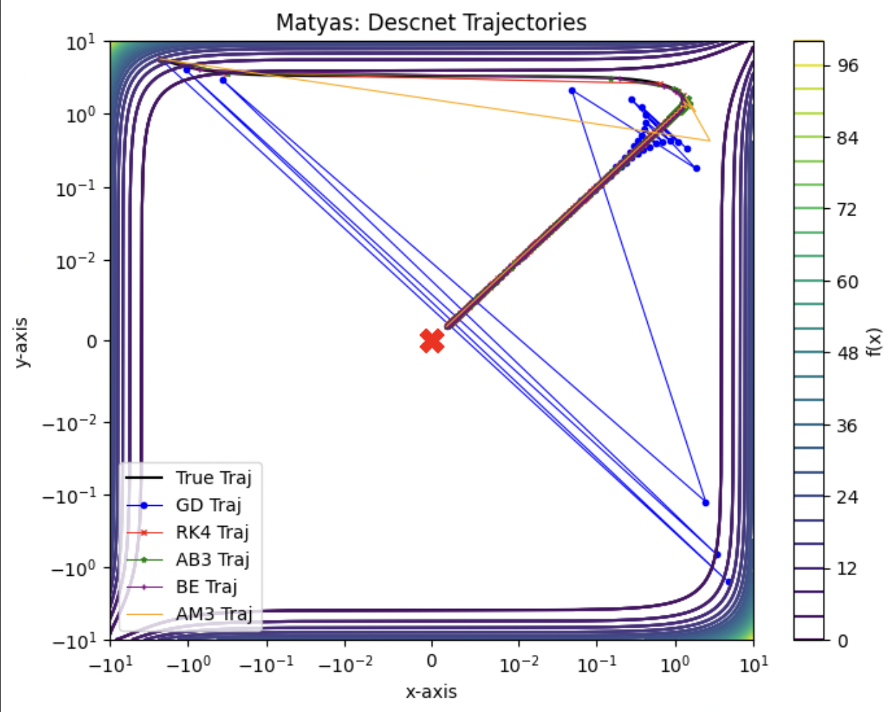
Figure 4: The plot on the left displays the gradient norm by number of iterations for the 5 methods used for the Matyas function. The plot on the right displays the trajectories for the 5 methods used for the Matyas function. Their results match each other.

In the case of the Matyas function, we see that gradient descent with Euler’s method once again converges the fastest in terms of number of iterations based on the left plot in Figure 4. Based on the left side plot in Figure 4, the second fastest method in terms of steps is AM3, with an average of 424.4 gradient evaluations based on Table 3. The paths of the methods are all very unique looking at the right side plot, but gradient descent takes the most interesting path, oscillating back and forth several times. Yet, Euler's still converges the fastest. AM3 also takes a similar path, which may be why it converges the next fastest.

Bohachevsky
 | Gradient Descent | RK4 | AB3 | Backward Euler | AM3
Step Size | 0.024 | 0.035 | 0.005 | 0.01 | 0.02
Avg Steps | 41.2 | 33.2 | 228.2 | 119.8 | 72.8
Avg Gradient Evaluations | 42.2 | 167.0 | 229.2 | 1318.8 | 291.4
Table 4: Table summary of results from Bohachevsky function
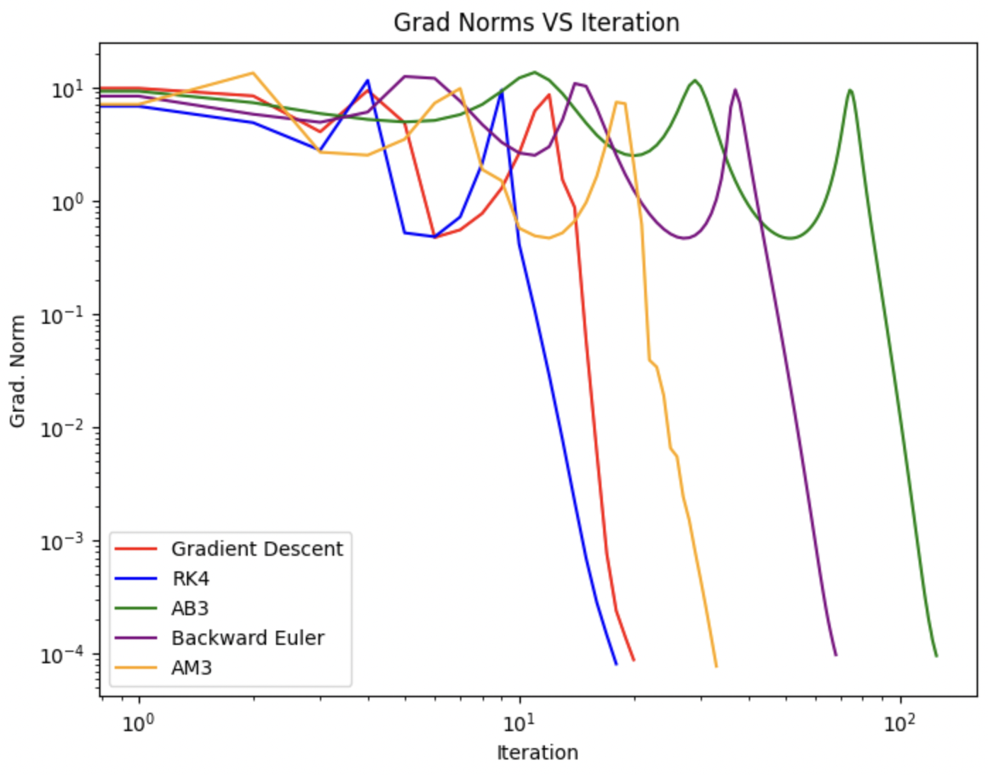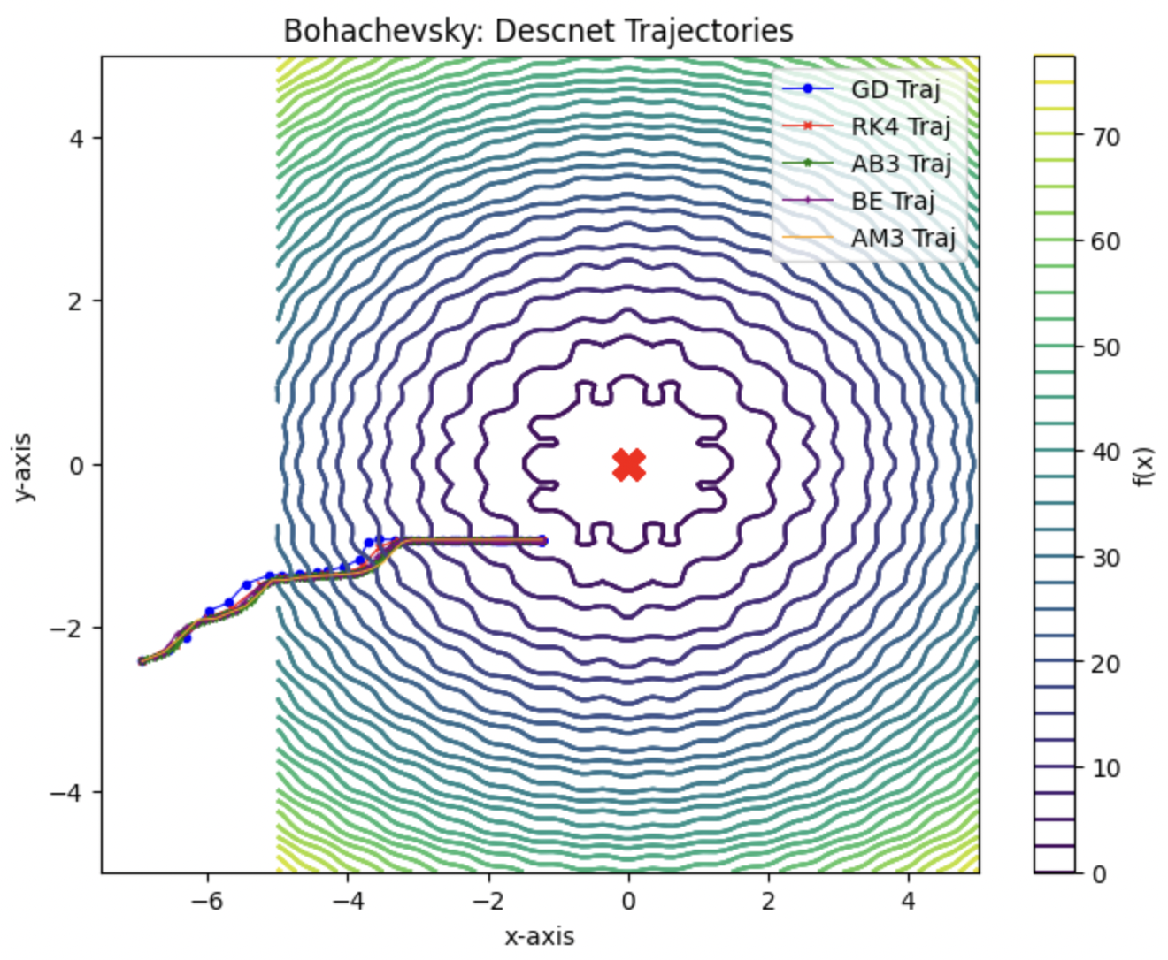
Figure 5: The plot on the left displays the gradient norm by number of iterations for the 5 methods used for the Bohachevsky function. The plot on the right displays the trajectories for the 5 methods used for the Bohachevsky function. Their results match each other.

In the case of the Bohachevsky function, we see that RK4 converges the fastest in terms of number of iterations based on the left plot in Figure 5. However, RK4 has an average of 167.0 gradient evaluations based on Table 4, while gradient descent only has 42.2 on average. The paths of all the methods take practically the same path looking at the right side plot in Figure 5.

Exponential
 | Gradient Descent | RK4 | AB3 | Backward Euler | AM3
Step Size | 1.1 | 1.5 | 5.4 | 1 | 21
Avg Steps | 5.2 | 8.0 | 5.8 | 4.2 | 1.6
Avg Gradient Evaluations | 6.2 | 41.0 | 6.8 | 17.8 | 45.2
Table 5: Table summary of results from Exponential function

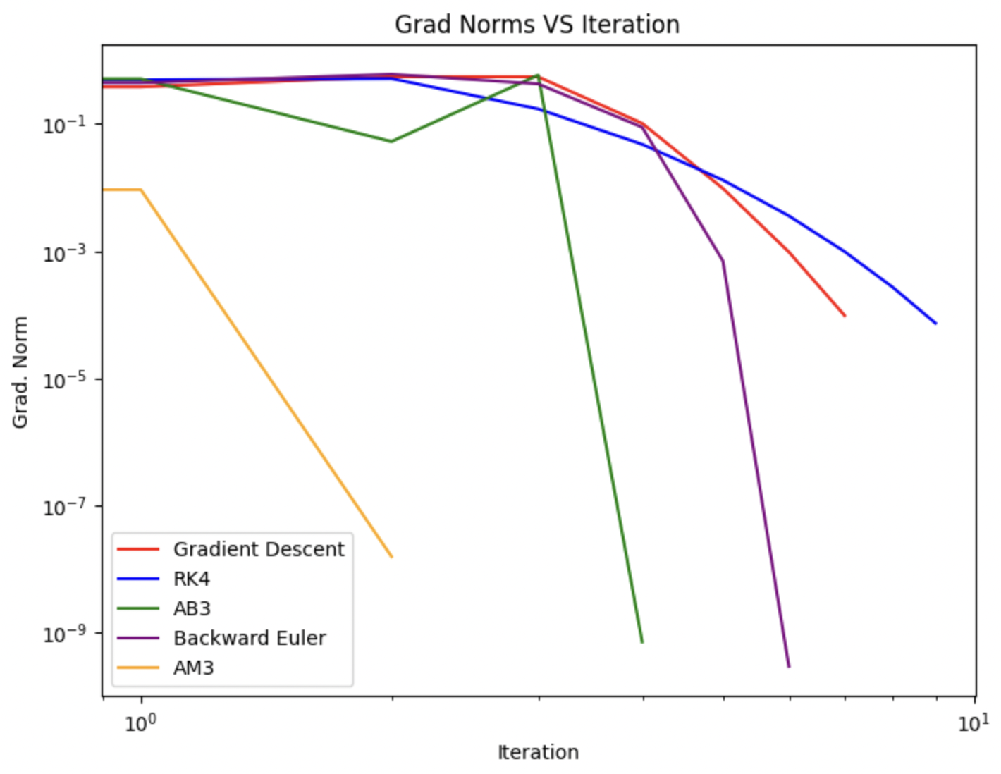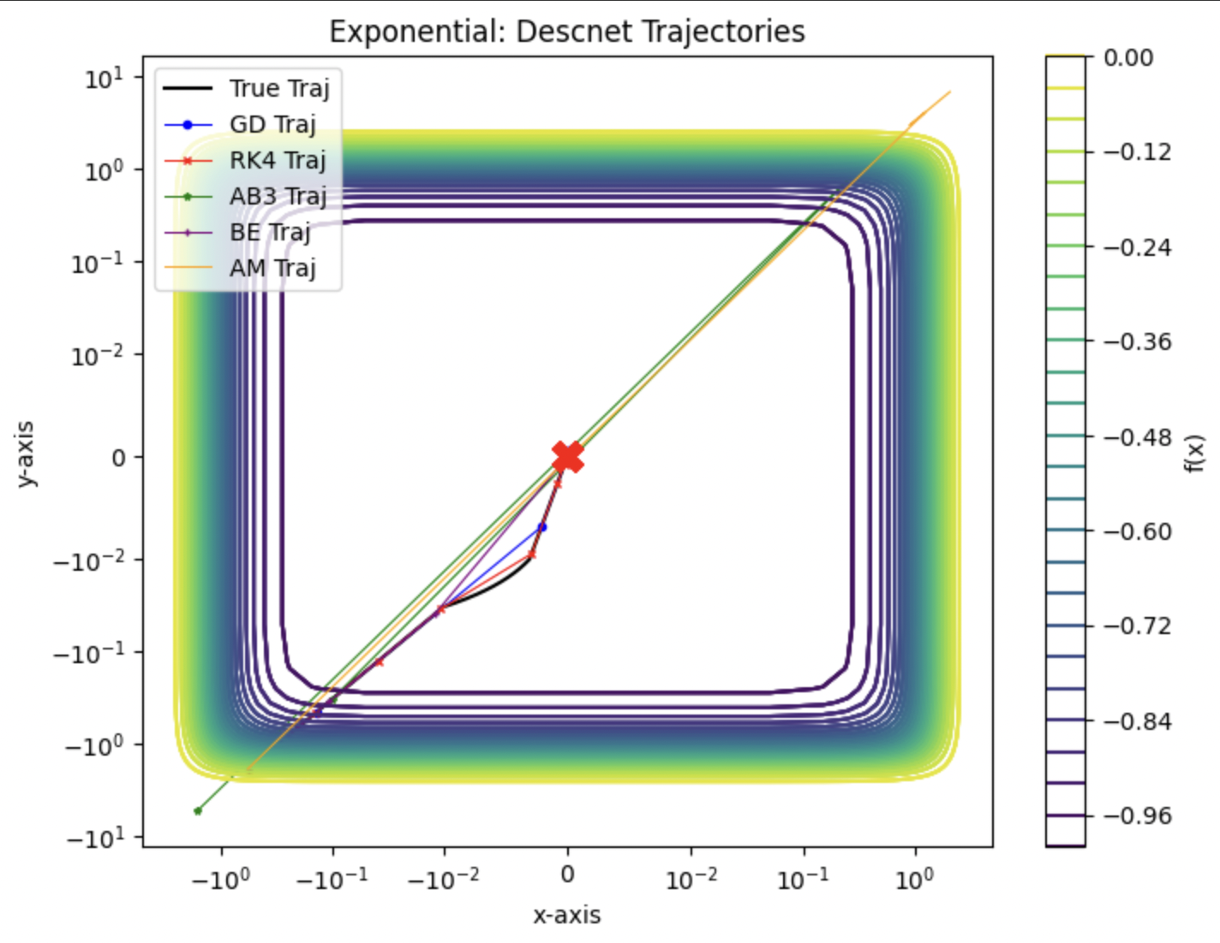
Figure 6: The plot on the left displays the gradient norm by number of iterations for the 5 methods used for the Exponential function. The plot on the right displays the trajectories for the 5 methods used for the Exponential function. Their results match each other.

In the case of the Exponential function, we see that AM3 converges the fastest in terms of number of iterations based on the left plot in Figure 6. However, AM3 has an average of 45.2 gradient evaluations based on Table 5, while gradient descent has only 6.2, which is the lowest. Looking at the right side plot of Figure 6, the paths of the methods - AM3 and AB3 - that are faster in terms of iteration took the same oscillatory path.

Discussion
It appears that Euler’s method is always more efficient in terms of computational costs even though it might not always be the fastest in terms of iterations. It is interesting to point out that methods with a certain kind of trajectory to the solution are always the faster ones in terms of iteration (albeit gradient descent always wins in terms of gradient evaluations). Another point to note is that gradient descent has some analytical solutions that let it converge in one step for the Brent and Exponential function, in which all of the other methods that used gradient descent as the first step - AB3 and AM3 - converged quickly too.
Thus the results from the experiment demonstrate that there is no evidence that using a different ODE method outperforms Euler's method. Except in rare and exceptional cases, none of the ODE methods had fewer total gradient descent evaluations on average, and never to the point in which the computational expense was worthwhile. In short, based on the experimental results, we conclude that the other ODE methods are less efficient than Euler's method in terms of gradient computations and often iterations, in spite of our assumptions.
First off, there were very few cases in which the ODE methods converged faster, as in through fewer steps, compared to Euler's method. The primary reason this is likely happening is that better approximations of the trajectory do not actually allow us to converge to the minimizer faster. The trajectory is essentially irrelevant information, meaning these methods put emphasis on solving a problem that is not actually useful for convergence.
It's a simplistic idea, but classic gradient might work best because it just prioritizes moving "down" towards the minimizer, without any other consideration of the path. In other words, having a better sense of the trajectory of the function is unnecessary for convergence to a minimizer. Hence, better approximations of the trajectory do not allow descent to get to the minimizer faster, which was the key assumption made in this experiment and likely why the results did not work as theorized. Solving an ODE just isn’t the same as solving the gradient flow problem, and the results reflect this.
As for the reasoning behind the step sizes being much smaller, it's possible that these ODE methods have a range of converging step sizes that do not outperform gradient descent. For example, the gradient descent proof shows the convergence range for gradient descent is (0, 2/L), given the gradient is lower-bounded and smooth. However, it is possible (and actually likely based on the results) that this is not the same range for the other ODE methods. If the convergence range for the step size has smaller values than that of gradient descent with Euler's method, this could be contributing to why these methods can't converge faster than Euler's method.
Initially, there was some speculation that there were some issues with stability, though this is less likely. Less stable methods will require smaller step sizes to approximate the trajectory, which could contribute to the small step sizes for the explicit methods Runge-Kutta 4 and Adams-Bashforth 3. However, implicit methods should generally be more stable than explicit methods, so this doesn't sufficiently explain why the step sizes for Adams-Moulton 3 and Backward Euler's method had such small step sizes. Actually, we'd probably theorize that the relative stability of these methods would allow us to take larger step sizes.
The issue with this reasoning is that, although the implicit methods are more stable than the explicit ones, they are only theoretically guaranteed to be stable in the sense of "approximating the trajectory with big step sizes," but not finding the minimizer with big step sizes. At the start of the experiment, the assumption was in part that we could take large step sizes for these stable methods because of their stability, but the step size for the trajectory doesn’t necessarily directly translate to the step size for descent. In short, stability is likely not the problem.
In the research completed for this project to discover why these methods aren't working, very little was found. Few people have attempted to use these methods in this way, or at least, they have not recorded it in academic papers. There was a lot of discussion of this idea from other students asking similar questions, usually in blogs and forums, which were not especially helpful (at least, not in the context of writing an academic report).
A few things were researched, as discussed in the "Proposed Methods" section. In most of the cases in which these alternative ODE methods are used, they are often used to either solve an actual ODE or update a feature of gradient descent [4],[6]. Most of the research is also done using stochastic gradient descent, which makes a direction comparison very challenging, even when the researchers appear to be doing something very similar, like in the case of the paper Runge-Kutta Method: A case study of SGD and Adam [3]. In short, it was challenging to find concrete reasoning regarding why this experiment failed, so the above theories are mostly speculation based on the results.
Other methods that improve gradient descent usually do so by using more information about higher derivatives or using momentum, like with Nesterov accelerated gradient descent. The difference with the method that we were attempting to use is that this method only improves the accuracy of the trajectory. Presumably, this is why methods like Nesterov accelerated gradient descent are well-researched and widely used, while the method discussed in this paper is not.
From this experiment, it's decided that using these ODE methods as an alternative to Euler's is not worthwhile in terms of better convergence for gradient descent. The experimental results confirm this and are assumed to be a result of the fact that having a better trajectory does not improve descent.

Conclusion
The usage of ODE methods in place of Euler’s method for gradient descent does not improve convergence in solving the gradient flow problem. Generally, these methods require more iterations, and, additionally, more gradient evaluations. This is likely because improving the approximation of the trajectory does not increase the rate of descent. In fact, this may actually cause additional issues by prioritizing information that is not useful in converging to a minimizer.

Bibliography
[1] Ardeh, M. A. (n.d.). BenchmarkFcns. https://benchmarkfcns.info/
[2] Zeltkevic, M. (1998, April 15). Runge-Kutta methods. https://web.mit.edu/10.001/Web/Course_Notes/Differential_Equations_Notes/node5.html#:~:text=Note%20that%20the%20RK%20methods,they%20are%20only%20conditionally%20stable
[3] Su, D., Jiang, Q., Liu, E., & Liu, M. (2024, March 26). Improving Optimizers by Runge-Kutta Method: A case study of SGD and Adam. IEEE Explore. https://ieeexplore.ieee.org/abstract/document/10477795?casa_token=uL44hl6f6gUAAAAA:9q7QqGUJFXuT_6FOFuHs6rdu1UxkDBrVKv9apCHWPcDRm86Ei1P7zt9aXwy6sFpQVCNSXvU
[4] Eftekhari, A. (2020, July 4). Implicit runge-kutta methods for accelerated unconstrained convex optimization | IEEE Journals & Magazine | IEEE Xplore. Springer Nature. https://ieeexplore.ieee.org/document/8979360/
[5] Burke. (n.d.). Washington. https://sites.math.washington.edu/~burke/crs/555/lectures/LMM.pdf
[6] Ayadi, I., & Turinici, G. (2021, May 5). Stochastic Runge-Kutta methods and adaptive SGD-G2 stochastic gradient descent | IEEE conference publication | IEEE Xplore. IEEE Explore. https://ieeexplore.ieee.org/document/9412831/
[7] Introduction to numerical methods and analysis with python (draft). 7.7. Implicit Methods: Adams-Moulton - Introduction to Numerical Methods and Analysis with Python (draft). (n.d.). https://lemesurierb.people.charleston.edu/introduction-to-numerical-methods-and-analysis-python/docs/ODE-IVP-8-implicit-methods-Adams-Moulton.html
[8] Am 213B prof. Daniele Venturi absolute stability of ... (n.d.). https://venturi.soe.ucsc.edu/sites/default/files/CHAPTER_5_Absolute_stability_of_numerical_methods_for_ODEs.pdf

Group Contributions
Asher:
- Runge-Kutta 4 Code
- Introduction/Motivation, Abstract, and Works Cited sections of paper
- Research for paper
  - Attempted finding applicable papers but mostly just found forum posts of students searching for similar answers as we were
- Preliminal slide organization
- Presented the Motivation section of the presentation
Christine:
- Group Coordinator
- Backward Euler code
- Sphere and Bohachevsky functions
- Final refinement of Results from code
  - Ensuring step sizes were correct, implicit methods worked, other debugging, etc.
- Code for plots
- Compiled results from code for presentation
- Created most of the presentation
- Edited the paper
- Presented the Experiments and Results section of the presentation
Genevieve:
- Group Coordinator
- Adams-Bashforth 3 code
- Exponential and Matyas functions
- Research for paper
  - Past research for reference and research about why method didn’t work as expected; the academic research ended up making most of its way into the “pre work” part of this paper because it wasn’t very helpful in determining why this wasn’t working
- Created some of presentation
  - A few slides not completed by another group member, plus original outline and uploading
- Discussion, Conclusion, and Experimental Results sections of paper
- Edited the paper
- Presented the Discussion section of the presentation
Shin:
- Adams-Moulton 3 code
- Brent function (and Ackley, which was later changed to Bohachevsky)
- Refinement of Results from code
  - Ensuring step sizes were correct, implicit methods worked, other debugging, etc.
- Research for paper
  - Past research for reference and research about what ODE methods are, how they work, how they are relevant to what we are doing, ect.
- Methods, Experimental Results and a little of the discussion section of paper
- Edited the paper
- Edited the slides
  - Added some details and made sure they were correct
- Presented the Proposed Methods section of the presentation

